Sequence to sequence models

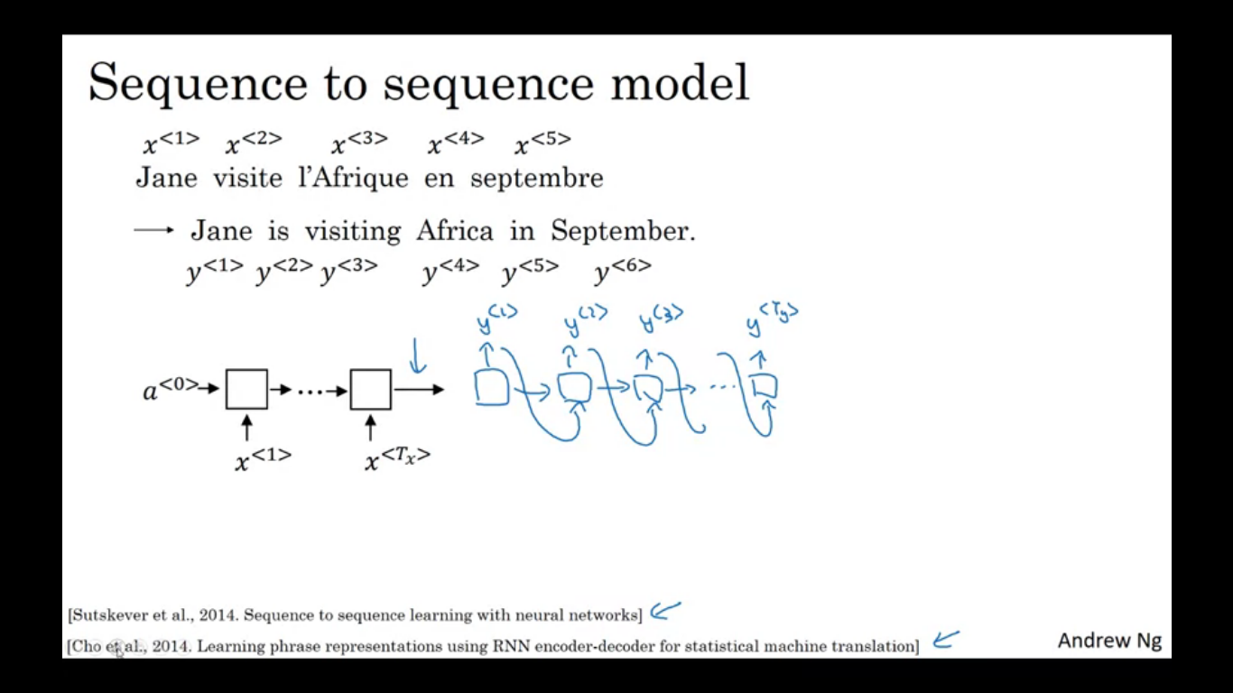

They are useful for everything from machine translation to speech recognition.

Let’s say we input a French sentence and we want it to translate to English sentence. We use x to represent words in the input sequence and y to represent words in the output sequence. How can we train a NN to input a sequence x and output the sequence y.

First we have a network called the encoder network be built as a RNN, which could also be GRU/LSTM. Feed in the input French words one word at a time. After infesting the input sequence , the RNN outputs a vector that represents the input sentence. After that we can build a decoder network which takes in input the encoding output by encoder network and then can be trained to give out translation one word at a time, until it outputs the end of token. If we train the model by giving enough pairs of English and French sentences this will work well.

This model uses encoder network whose job is to find the encoding of the input French sentence and then use a decoder network to output English sentence. An architecture similar to this works for image captioning.

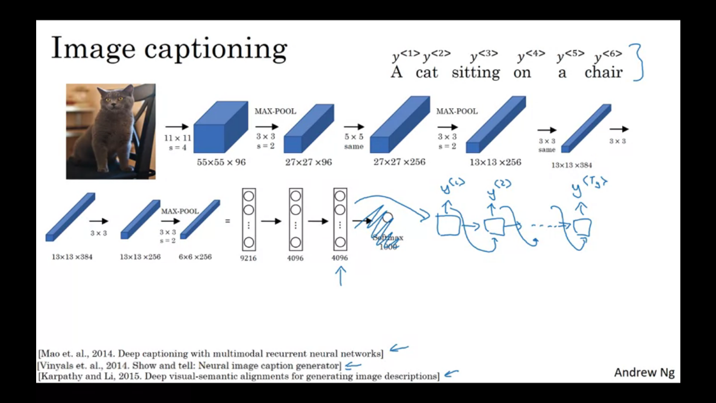

How do we build a NN to input an image and output a caption like the phrase. We can input an image in a CNN like Alexnet and have that learn an encoding or learn a set of features of input image. If we get rid of the final softmax unit the Alexnet can give us the 4096 dimensional feature vector which is used to represent the picture of a cat. So this pretrained network can be encoder of this image. We can take this 4096 dimensional feature vector and feed it to RNN whose job is to generate the caption one word at a time.

**Picking the most likely sentence**

**Machine translation as building a conditional language model**

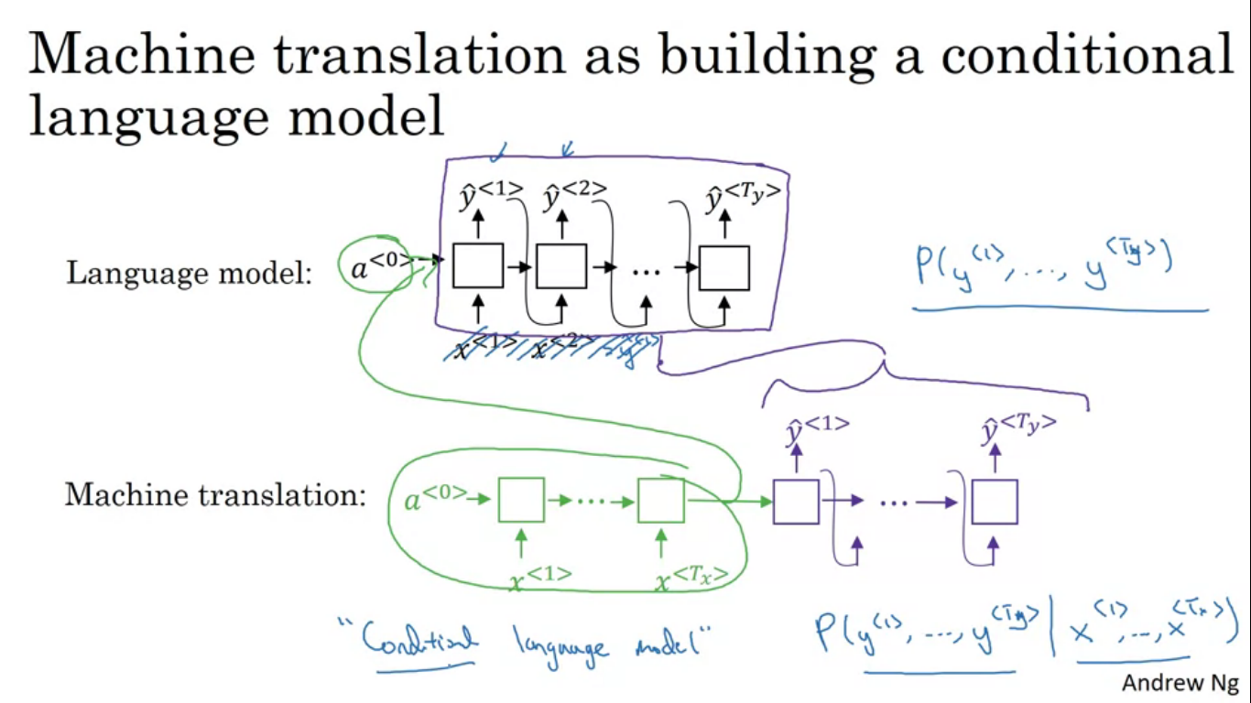

In language modelling, the model as shown allows you to estimate the probability of a sentence. The machine translation model shows the encoder network in green and the decoded network in purple. The decoded network looks pretty much identical to the language model. So machine translation model is very similar to the language model except that always starting along with a vector of all zeros it instead has an encoded network that figures out some representation for the input sentence and starts off the decoded network with the representation of input sentence rather than of all zeros.

Instead of modelling the probability of any sentence it is now modelling the probability of output translation conditioned on some input French sentence. This is why it is a conditional language model.

Given this input French sentence, the model might tell you what is the probability of different corresponding English translations. If we sample words from this distribution P(Y/X) maybe one time you get a pretty good translation but another time maybe we get another translation. So when we are using this model for machine translation we are not trying to sample at random from this distribution, instead we would find a English sentence y that maximizes that conditional probability. So in developing a machine translation system we need to come up with an algorithm that can actually find the value of Y that maximizes y<1>,...y<Ty>. The most common algorithm for doing this is called beam search.

**Why not use just greedy search?**

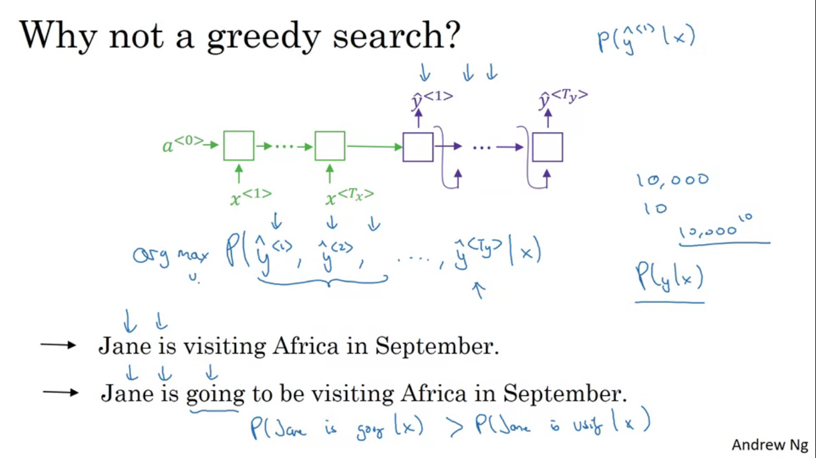

Greedy search is an algorithm from computer science which says to generate the first word just pick whatever is the most likely first word according to your conditional language model. We then pick the second word that seems most likely and similarly for the next words.

Given two translations it will say that P(y/x) is higher for the first translation. But if the algorithm has picked ‘Jane is’ as the first two words for both translation, because going is a much more common word so the probability of ‘Jane is going’ might be higher than the chance of ‘Jane is visiting’ so if we have a translation that takes into account the first three words, the option 2 is a better choice since it will have larger probability. But this ultimately ends up resulting in a less optimal sentence.

If you want to find the sequence of words y1,y2 all the way upto the final word that together maximizes the probability it is not always optimal to pick one word at a time. Total number of combinations of words in the English sentence is exponentially large, so if you have 10000 words in a dictionary and if we are contemplating translations that are 10 words long then there are 10000^10 possible sentences that are 10 words long. It is impossible to find from such large space which is why we use approximate search algorithm. Approximate algorithm always tries to pick the sentence that will always maximise the conditional probability.

**Beam Search**

**Step 1**

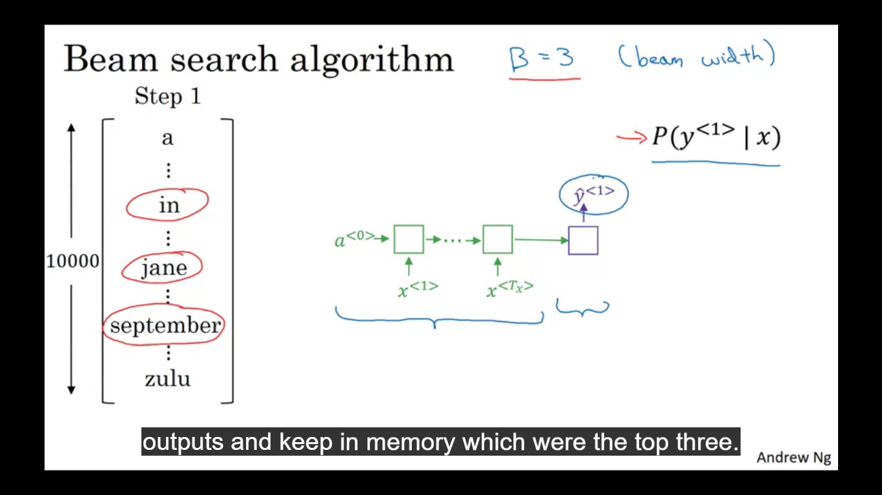

Given an input French sentence you don’t want to output a random English translation, rather we want to output the most likely English translation. The first thing beam search tries to do is to try to pick the first word of the English translation. So out of the 10000 words in the vocabulary , we want to find out the probability of the first output y given the x French input, from the help of encoder and decoder network as shown. Greedy search will only pick one most likely word, beam search considers multiple alternatives.

Beam search algorithm has a parameter called B (beam width) and this example we set it to 3, this means that beam search will consider three possibilities at a time. Let’s say the three possible words for the first word are ‘in’ , ‘jane’, ‘september’. Then beam search stores in its memory that it wants to try out all three words.

So first we run the French sentence in the encoder network and the first step of decoder network which is a softmax output overall 10000 possibilities out of which we keep in the memory the top three.

**Step 2**

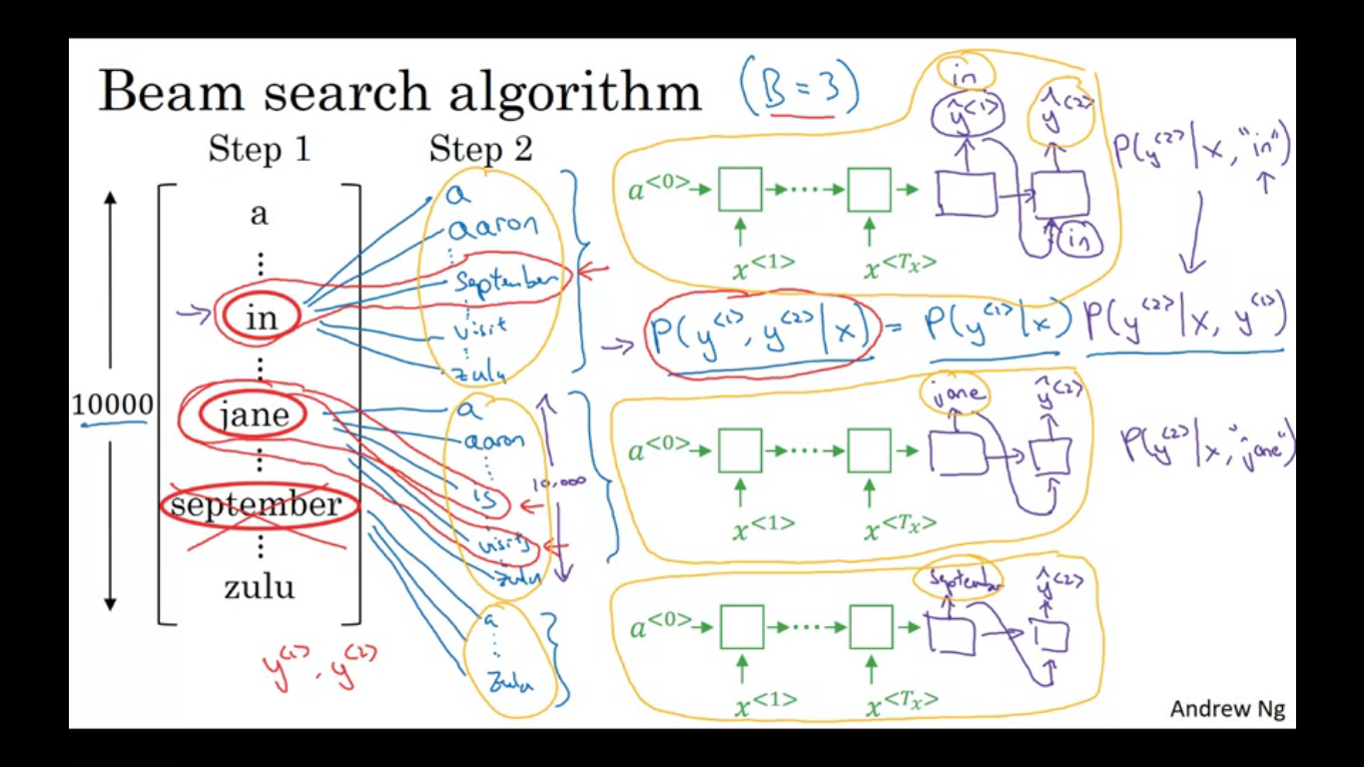

Having picked in the three words the beam search now considers for each of these three choices which would be the second word. To do that we do as shown in the encoder-decoder network shown in blue and green ink. So we evaluate what is the probability of the second word given the input French sentence and the first word in the translation is the word in. So here actually we are finding the pair of the first and second word which is most likely. As shown in the figure. So in this second step we end up considering three times the vocabulary which is 30000 words since 10000 each for in, Jane and September. We evaluate the probability of first and second word and then pick the top three , so we cut down the 30000 possibilities to three again.

So the two most likely words for the sentence are as marked in red so it is rejecting September as a candidate of the first word of the output English translation. As the beam width is 3 at every step we instantiate three copies of the network to evaluate these partial sentence fragments and the output

**Step 3**

We now consider what can be the third word just like we have done previously.

Adding one word at a time that beam search decides the correct output terminated by EOS (end of sentence).

**Refinements to beam search**

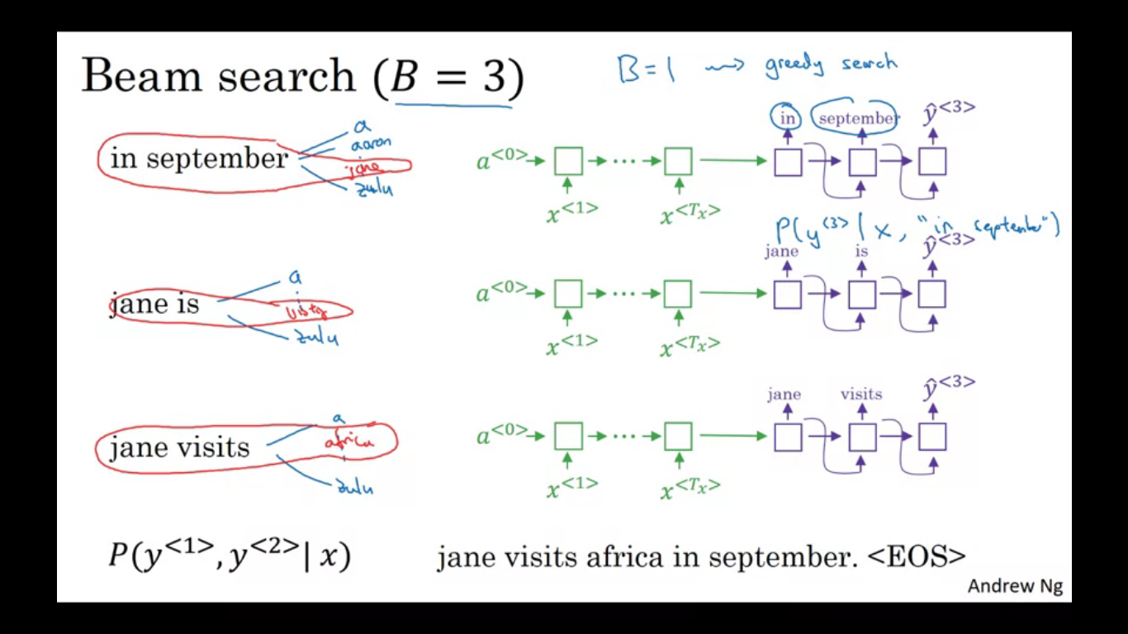

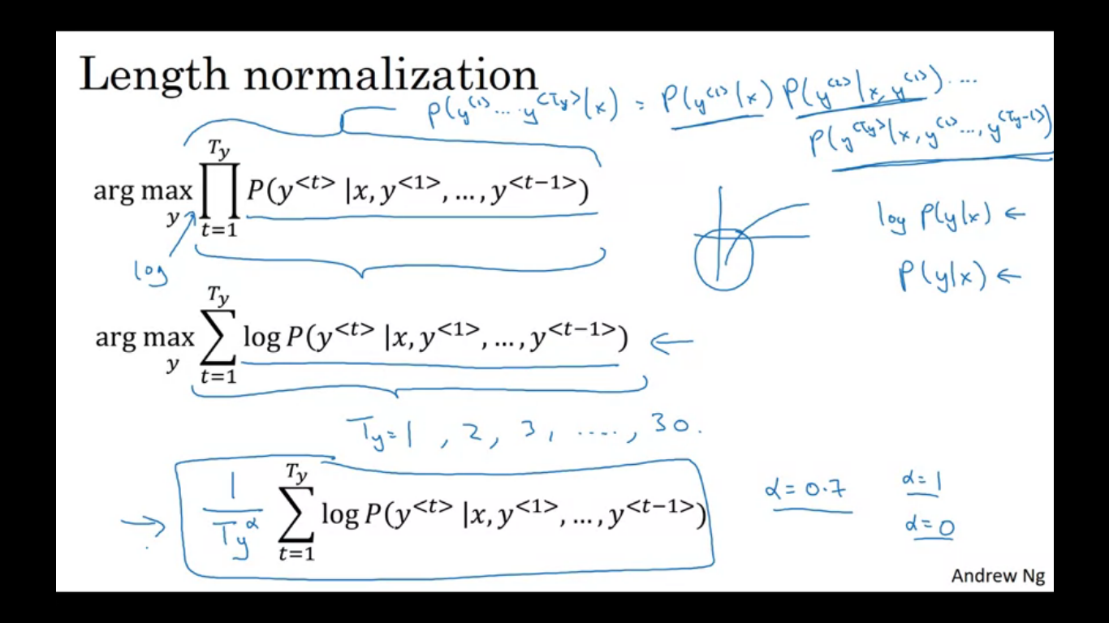

Length normalization is a small change to beam search algorithm that can help us get better results. Beam search is maximising the probability equation written in image. The probabilities written are all numbers less than 1,and multiplying a lot of numbers less than 1 will result in a tiny number which can result in a numerical underflow, meaning it is too small for the floating part representation in your computer to store accurately. So in practice, instead of maximising this product we will take logs converting the log of a product to a sum of a log, and maximising this sum of log probabilities should give the same result. With logs we end with a more numerically stable algorithm that is less prone to rounding errors.

Log function is a strictly monotonically increasing function we know that maximising log p(y/x) gives the same result as maximising p(y/x).

If we have a long sentence then the product of probability of that sentence is going to turn out quite low. This objective function defined in the first line has the undesirable effect of unnaturally preferring very short translations, since in that lesser probabilities will be multiplying which are less than 1. Similar thing is true for the second equation also, the log of a probability is always less than or equal to 1.

Instead of using the log equation as the objective we are trying to maximise, one thing we can do is normalize this by the number of words in your translation so this takes the averga eof the log of the probability of each word, and this significantly reduces the penalty for outputting longer translations. In practice instead of dividing by Ty , the number of words in the output sentence =, sometimes we use a softer approach which is Ty^alpha where alpha=0.7. so if alpha =1 then completely normalizing by length if, alpha=0, then we are not normalizing at all since Ty^0=1, so we remain somewhat in between full normalization and no normalization. Alpha is another hyper parameter we can tune to get the best result.

When we run beam search we see a lot of sentences with length =1, 2, 3..., 30, we consider the output sentence up to the length of 30, with the beam width of 3 we keep three possibilities for each of these possible sentence lengths. Then we look at all the output sentences and score them against the score in the box, (third final). We finally pick the sentence that has achieved highest value on this normalised log probability objective.

**How do you choose the beam width B?**

The larger B is the more possibilities you are considering and thus the better sentence we find. But the larger B is the more computationally expensive the algorithm is as we are keeping a lot more possibilities around.

If setting the bam width small then we get worse result but it is faster computationally since we are keeping less possibilities. In production systems we keep the beam width to maybe around 10, a beam width of 100 will be considered very large for a production system depending on the application.

**Error analysis in beam search**

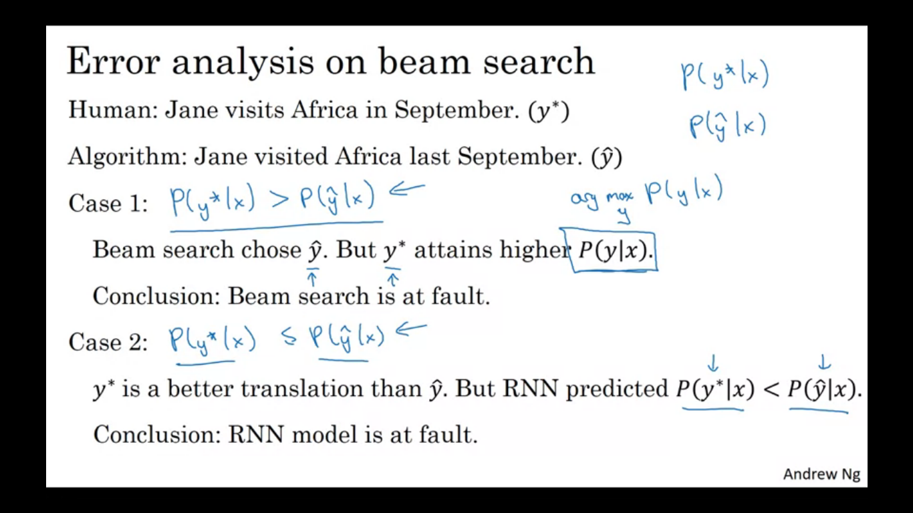

Beam search is an approximate search algorithm also called a heuristic search algorithm and so it doesn’t always output the most likely sentence.

Our model has two main components, there is a NN model, the sequence to sequence model (RNN encoder and decoder) and we have our beam search algorithm. As getting more training data never hurts similarly increasing the beam width never hurts, but just as getting more training data by itself might not get you to the level of performance you want, in the same way increasing the beam width by itself might not get you to where we want to go.

We need to compute P(y*/x) as well as P(y^/x) and see which of these two are bigger. Depending on which of the two cases (>/<=) hold true we can then affiliate the error to one of the RNN or the beam search being at greater fault. Which is at fault is shown as though in this image.

So through the process of writing in the tables we can then carry out error analysis to figure out what fraction of errors are due to beam search vs RNN model. If beam search has more error fraction then it is worth increasing the beam width, in contrast if we find the RNN model is at fault then we can do a deeper layer of analysis to try to figure out if we want to add regularization or add more training data, etc.

**Bleu Score (Bilingual Evaluation Understudy)/Optional**

Given many equally good translations it automatically generates a score which is used to measure how much better is a machine translation. Intuition behind this is we are going to look at the machine generated outputs and see if the types of words it generates appear in atleast one of the human generated references. These human generated references would be provided as part of dev set or test set.

One way to measure how good machine translation output is to look at each of the words in the output and see if it appears in the references. This would be called precision of machine translation output. But this would not work well so we would be using the modified precision in which we give credit only up to the maximum number of times it appears in the reference sentences. In reference 1 the gets a score of 2/7.

**Attention model intuition**

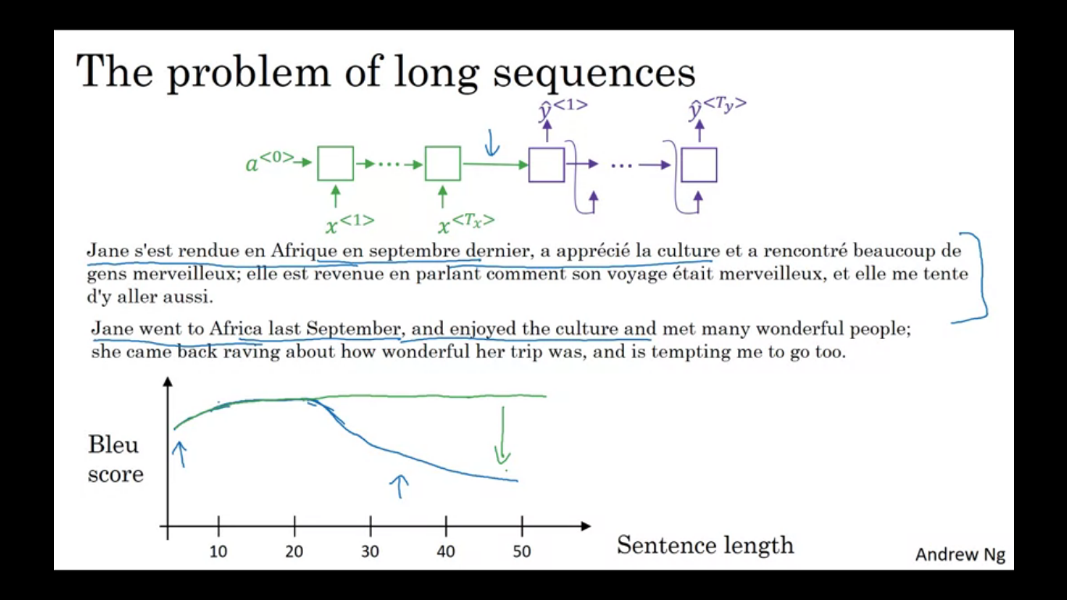

Given a very long sentence, what we are asking this green encoder to do is memorize the whole sentence and then save in the activations conveyed later. For the purple network the decoder network then generates the English translation. A human translator on the other hand works part by part. Encoder-decoder architecture works quite well for short sentences but for long sentences the performance comes down.

The attention model translates a bit more like humans might looking at part of an attention at a time. Then the machine translation score might increase with increasing words because by working one part of a sentence at a time.

**Attention model intuition**

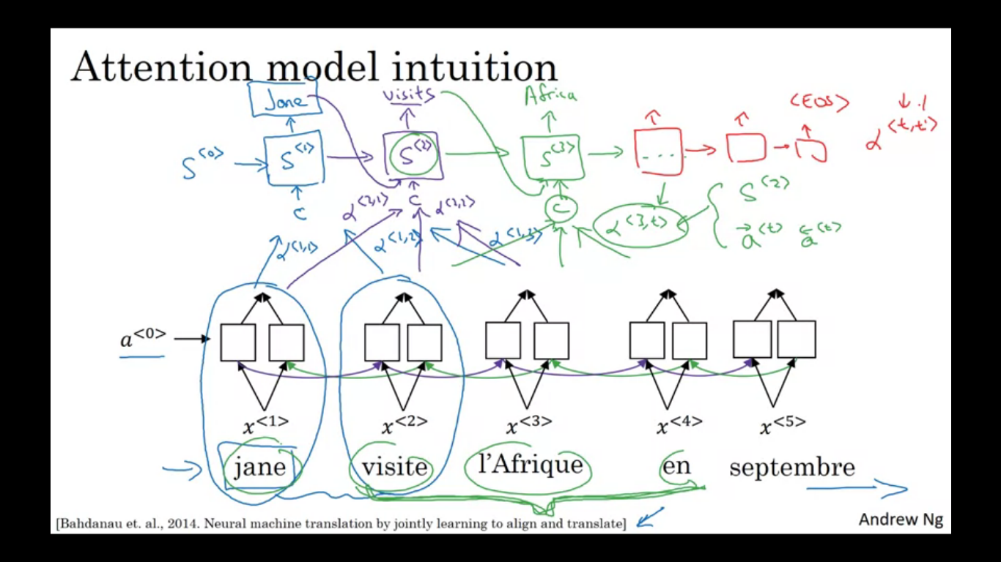

We have a RNN bi-directional to compute some set of features for each of the input words. Using a bi-directional RNN , for each of the words we can compute a set of features about words in the sentence and surrounding words.

Now to generate the English translation we are going to use another RNN. The question is when we are trying to generate this output, what part of the input French sentence should you be looking at? You should be looking primarily at the first word and some word nearby.

What the attention model will be computing is a set of attention weights and we are going to use alpha<1,1> to denote when we are generating the first word, how much should you be paying attention to this first piece of information here. We also come up with a second called as attention weight alpha<1,2> which tells us what we are trying to compute the first word of Jane, how much attention should we be paying to this second word and similarly alpha<1,3> and so on. This tells us the context we should be paying attention to and is input to this RNN unit and then try to generate the first words.

For the second step of RNN we are going to have a second hidden state s<2> and we are going to have a new set of attention weights alpha<2,1> , alpha<2,2> and so on.

As shown in the image, this way RNN marches forward generating one word at a time until it generates EOS and at every step we have alpha<t,t’> which tells us when we are generating t th English word how much attention should we pay to t’ French words.

**Attention model**

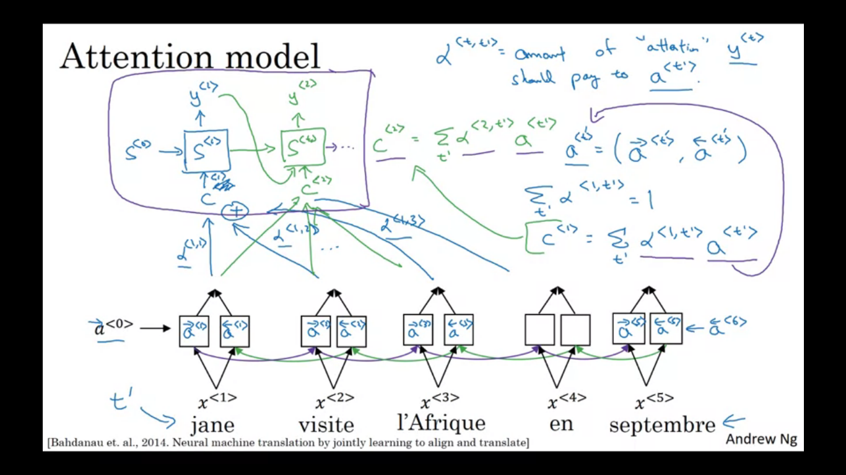

We saw how attention model allows a NN to pay attention to only part of an input sentence while it is generating a translation. Same as previously, we have an input sentence and we use a bi-directional RNN to compute features on every word. a<t> is the feature vector of time step t, containing both forward and backward recurrence.

Next we have a single direction RNN with state s to generate the translation. So in the first time step it should generate y1 and just will have as input some context C which depends on attention parameters which are alpha<1,1> ,alpha<1,2>, ... . These tell us how much the context would depend on the features we are getting from different time steps. The context is actually a weighted sum of the features from the different time steps weighted by these attention weights. All attention weights will be non negative and they sum to 1. The formula of context is as shown is the sum of weighted activations. Alpha <t,t’> si the amount of attention that y<t> should pay to a<t’>. In simpler words when you are generating t th output word how much should you be paying attention to the t’ th input word. Similar we generate for the next time step.

This network is a RNN where context word is an input and can translate one word at a time.

**How to compute these attention weights?**

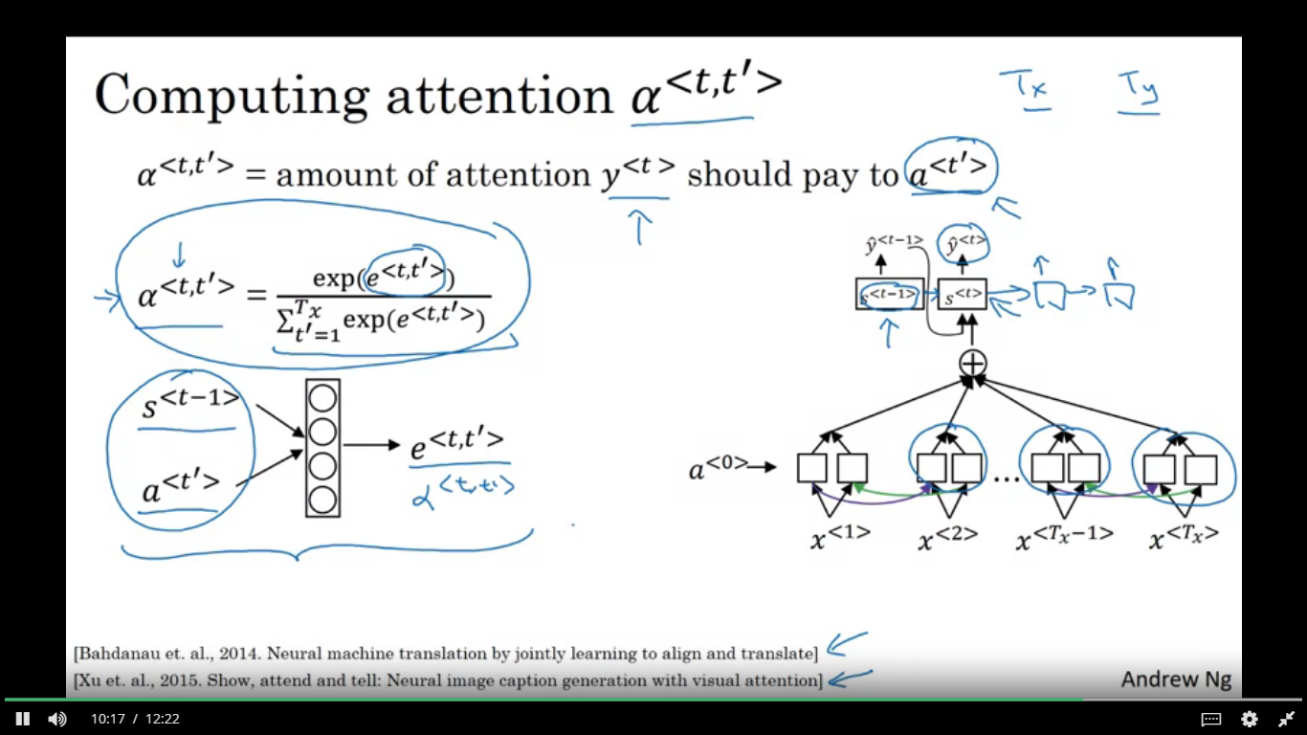

We compute these terms e^e<t,t’> and then use softmax to make sure these weights sum to 1 if we sum over t’. To calculate the parameters e is a way to use a small NN as shown. S<t-1> is the NN state at previous time step and that is one input to the very small NN and a<t’> are the features from time step t’ is the other input.

If we want to decide how much attention to pay to the activation of t’ well the things that seems like it should depend the most on is what is your own hidden state activation from the previous time step. The things it depends most own is what is the own hidden state activation from previous time step and for each of the words, their features.

So alpha<t,t’> and e<t,t’> depends on these two quantities s<t-1> and a<t’>. But we don’t know what the function is , so we train a very small NN to learn the function.

One downside of this algorithm is it does take quadratic time/cost to run this algorithm. If you have Tx words in input and Ty words in the output, then the total number of these attention parameters is going to be tx*ty. And so this algorithm runs in quadratic cost. Although in machine translation, no input sentence is actually long, maybe quadratic cost is acceptable. Although there is some research work on trying to reduce this cost as well.

Date normalization problem

We input a date and normalize it into standard format using a NN/sequence to sequence model.

**Speech recognition**

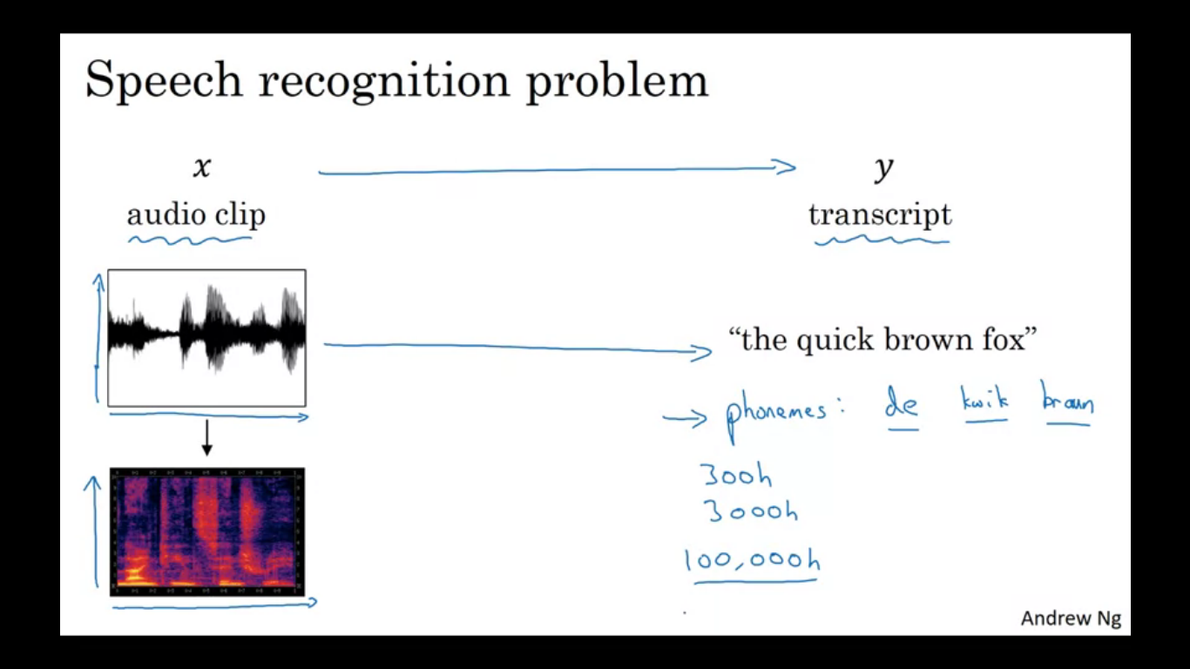

We are given an audio clip x and our job is to automatically find the text transcript y. In the plot of audio clip, the horizontal axis is time. A microphone measures miniscule changes in air pressure and the way we hear the sound is because our ear is detecting little changes in air pressure probably generated by a speaker or headset. The plot is basically air pressure against time.

There is a common pre-processing step for audio data, which is to run your raw audio clip and generate a spectrogram. This is a plot where the horizontal axis is time and vertical axis is frequencies and intensity of different colours shows the amount of energy. This kind of pre-processing is applied before an audio is passed into a learning algorithm.

Once upon a time, speech recognition systems were built using phonemes. Phonemes are actually kind of the representation of how a word is pronounced. But with end to end deep learning we are finding that phonemes are no longer necessary.

One thing that made this possible is availability of much larger datasets. Best commercial systems are now trained on over 100000 hours of audio.

How do we build a speech recognition system?

We could use attention models where on horizontal axes you take in different time frames of audio input. And then we have an attention model which generates the output.

**CTC cost of speech recognition**

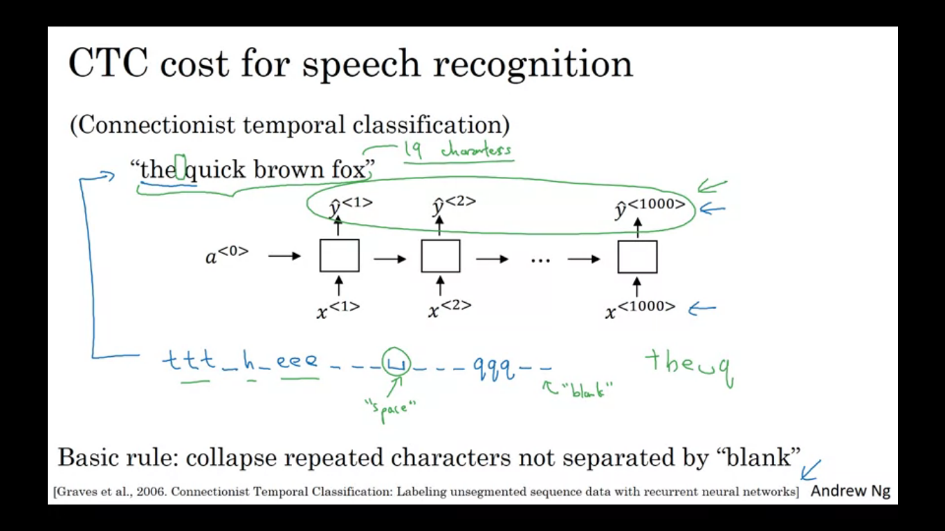

CTC stands for connectionist temporal classification. We are going to use a NN with equal number of input x and output y, here we have drawn only uni-directional RNN, but in practice it is bi-directional LSTM or GRU. In speech recognition usually the number of input time steps is much larger than the number of output time steps. example you have 10 seconds of audio and features come in 100 hertz or 100 samples per second then a 10 second audio clip end up with a 1000 input. The output might not have 1000 alphabets.

The CTC cost function allows the RNN to generate an output as shown and the basic rule of CTC is to collapse repeated characters not separated by a blank.

**Trigger word detection systems**

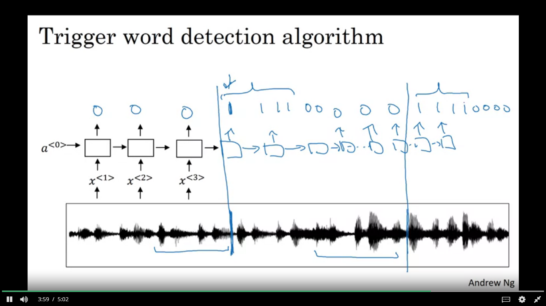

We take an audio clip and generate audio features x1.x2,x3... that we pass through an RNN, and all that remains to be done is to define the target labels Y. If we know the point where the person has just finished we can set the target labels to be zero for everything before that point and right after that to set a target label of 1. One disadvantage of this is that creates a very imbalanced training set. We have a lot more zeros than we want.

So one other thing we could do is instead of setting only single time step to output 1 we can make it output a few 1 for several times for a fixed period of time, before reverting back to zero. This action evens out the ratio of ones and zeros.